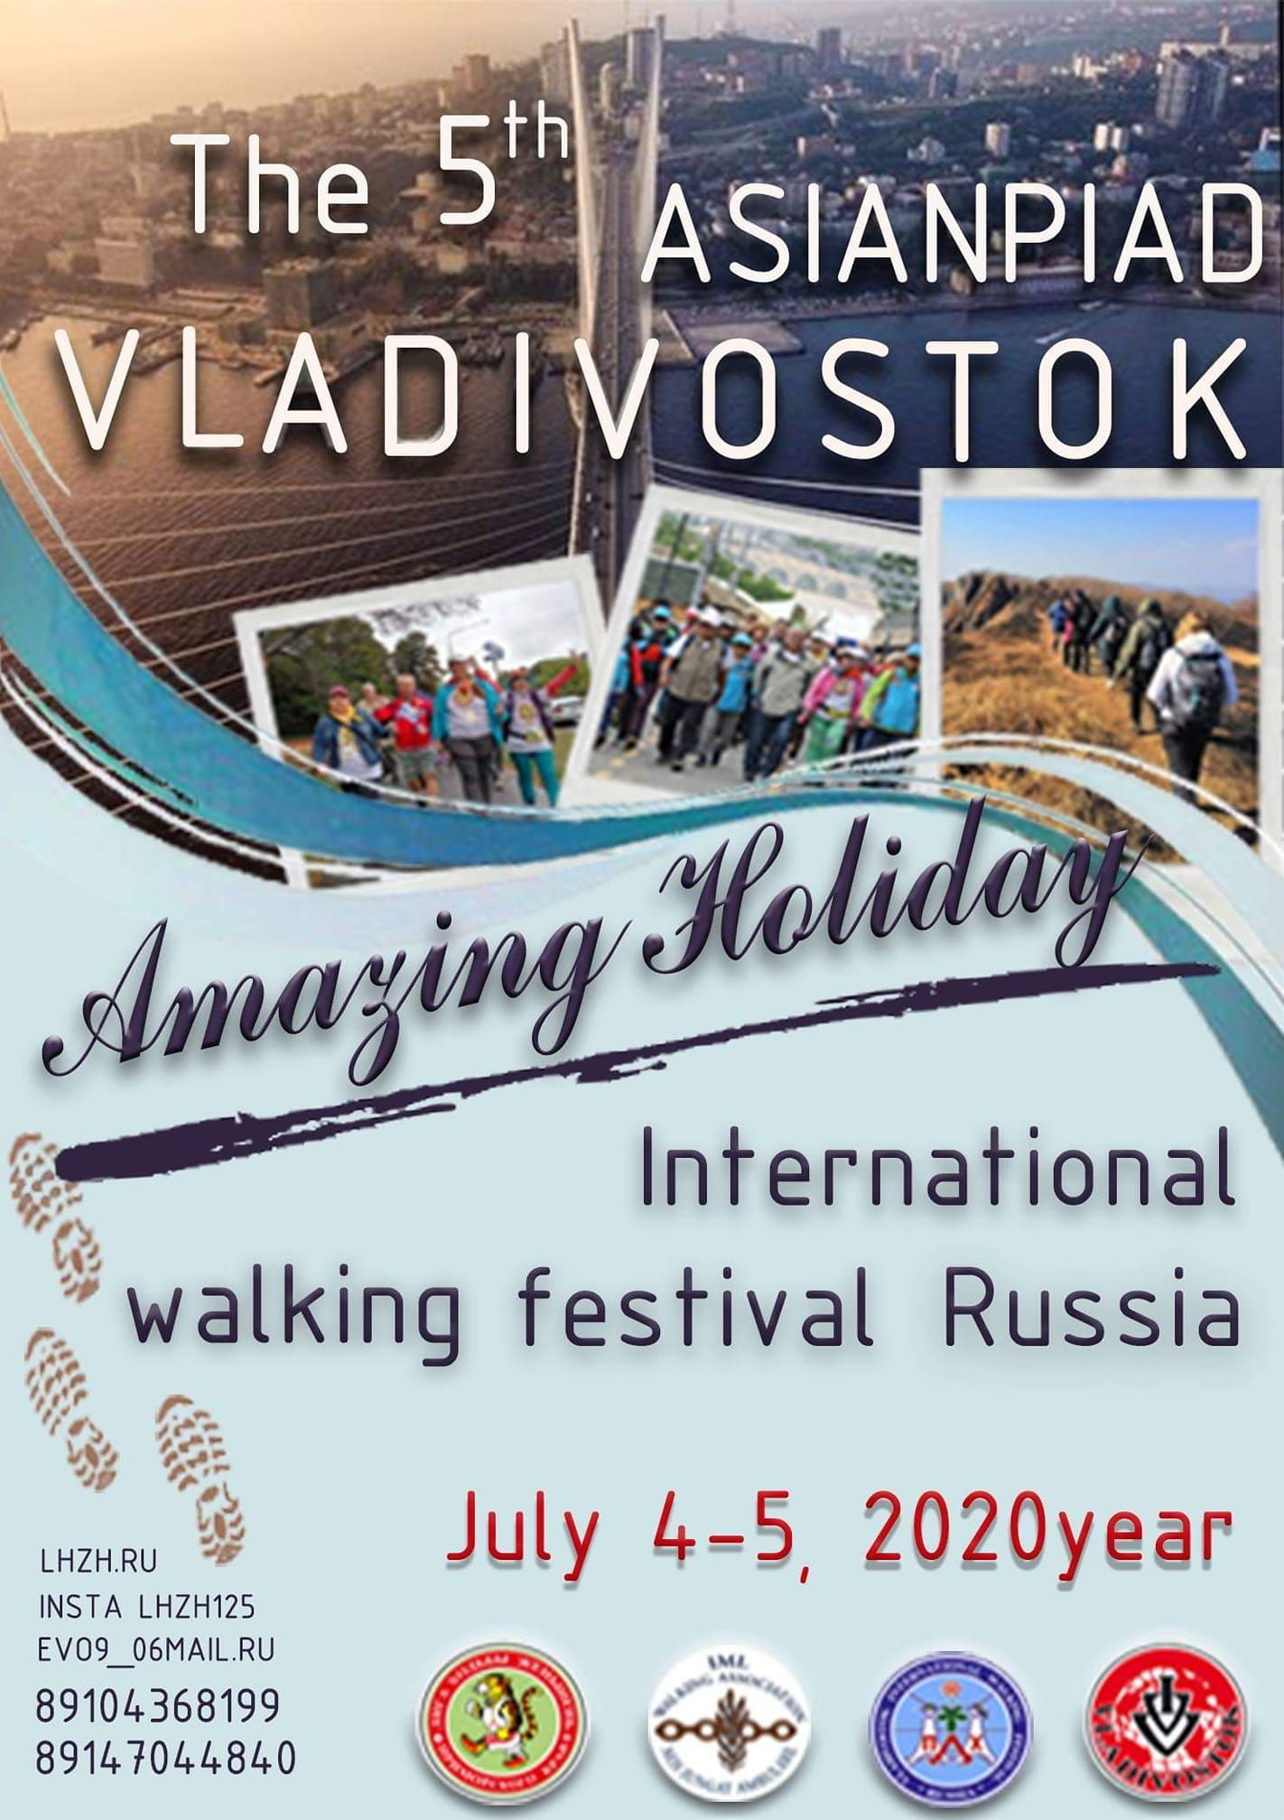
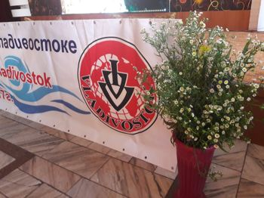

29/07/2020

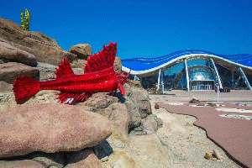
Tour of the Russkiy Island and Oceanarium/Aquarium
Take a walk onto the picturesque Tobizin Cape. In the afternoon swim in the open sea, have a lunch on the beach and visit the Aquarium in the evening.
Scientific and educational complex "Primorski Oceanarium". The total area of the interior space is larger than 37,000 m²: almost five football pitches are hidden in a building that looks like an open white shell. The Oceanarium is the third largest aquarium in the world. In the left wing of the Oceanarium is a main tank with an underwater tunnel of 70 meters. In the right wing there is a Dolphinarium with a swimming pool, Arena and grandstands, which can accommodate 800 spectators, 2 shows daily. Here you find fauna from the coast and from all oceans and climatic regions of the earth. Nice open-air recreational area surrounds the Oceanarium.

30/07/2020
Boat trips to the islands near Vladivostok
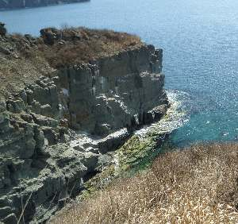

Shkot Island. 20 km Walks around the island. Beautiful scenery.

01/07/2020
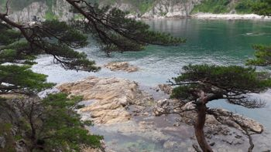
Departure for the Hasan District walk on the Jankowski Peninsula/Sidimi.
Jankowski Peninsula, also known as Sidimi, is located in the western part of the Gulf of Peter the Great, 1.5 hours by boat or 2,5 hours by bus from Vladivostok. It separates the Bay of Slavyanka from the shallow lagoon Lebyazhaya and the bay of Narva. Today's name the peninsula got in honor of a great local landowner and researcher of the late 19th century Mikhail Jankowski. In the northwest, the peninsula is connected to the mainland by a low marshy isthmus. In the eastern part of the peninsula is the Geck Bay, named after the first settler Fridolf Geck, in the southeast is Tabunnaya (Herd) Bay, in the southwest is the Minonoska Bay. The extreme northern tip of the peninsula is Brynner Cape, also named after the first settler and enterpreuner. To the south of the peninsula are the islands of Gerasimov and Sidorov, and to the east the Krolichy/Rabbit Island. The highest point of the peninsula is at an altitude of 248 m. The relief of the peninsula is mainly mountainous. The coasts are mostly steep and rocky, in the north west plain and partly flooded. Flora at the Jankowski peninsula is represented by woods and large open spaces of grass. Ginseng, Amur cork tree, Aralia, etc. grow here wild. Once the place was famous for the wild animals such as tiger, leopard, boar, deer and so on. Now they live in the special protected reserve area on the mainland, not very far from the peninsula. The coast with numerous coves and sandy beaches is very picturesque, and it is an ideal place for walks.

02.07 2020

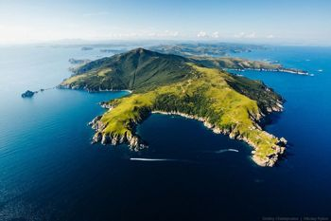
Gamov Peninsula is located in the southern part of Peter The Great Bay. The Gamov peninsula houses the village of Vityaz, once a marine scientific and research station. The extreme southern point of the Gamov peninsula is also named after Gamov, the Russian Navy officer of the 19th century. The famous lighthouse is located at the Gamov Cape, in the register of beacons of Russia it is under the number 1.
The terrain of the peninsula is mountainous, one hill replaces the other, and the hills cross over the valleys and streams. Gamov Peninsula's highest peak is Mount Tumannaya/Foggy, height 506 meters, is clearly visible at the entrance to the village of Vityaz with the knight's pass. The coast of the peninsula has both soft and rocky. In the coastal waters are the islands of Taranceva, Aleksejev, Astafyeva, with rocks, underwater and surface.
Residential settlements of the Gamova peninsula- The village of Vityaz and the lighthouse Gamow. The eastern water area of ​​the peninsula together with the 500 meter buffer coastal zone are part of the Far East State Marine Reserve.
The Gamova peninsula fascinates everyone who has ever visited this country. Water of amazing beauty, bizarre rocks, rare birds and plants can be found here at every step. In the spring, it blooms on the peninsula
The sea of ​​Japan off the coast of the peninsula in the summer is heated to + 23 degrees, the water here is very clean, the underwater world is rich. In a bay Alekseeeva a place or permanent residence or seals-Larga. The area of ​​Vityaz bay is rich in grater and Kempten, shrimp and scallops, aktinijami and mussels. In these waters, it is very common to meet a shark, just off the coast of the peninsula was the first shark attack on a man in Primorje in the summer of 2011.
In the bay of Vityaz, near the islands of Taranceva, there are habitats or Octopus doflejna. It is a giant Pacific Octopus, the weight is usually 20-25 kilograms, but there are also 50 kilograms or specimens. Octopus is one of the attractions of this part of Peter's Great Bay.
It is in the south of Primorje living birds and animals and growing plants, recorded in the Red book. It is Amur tiger and bear Himalayas, spotted deer and roe deer, raccoon dog and Ushuri cat, weird bird species-Mandarin, owl Iglonogaja, Daur and Japanese cranes. Weird species of butterflies such as Pyri Artemis and Hvostonosec Spring can be found here. Linden and oak, birch and Aralia grow in the forest near the pine tree; Lilies and irises, valerian and chamomile and other taiga, as well as subtropical plants bloom.
The rocks have a nice shape and are like hanging. The landscape is unique, looks incredibly majestic and brings some thoughts. In addition, one more island borders the bay. The locals called it the languishing heart. "Such a romantic name that is received due to the presence of a natural phenomenon-in a rock bath is a stone, which starts to move in the stormy weather, clashing with other stones, why the sound is born, similar to the knocking There is a legend that if the place to make a wish, it will certainly become a reality.
This is one of the most favorite vacation destinations.
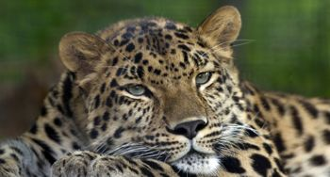
National Park of the land of leopards, located in Primorski kraj on April 5, 2012 with the main purpose - to preserve and restore the population of the rarest big cat in the world - the Leopard of the Far East, whose number in Russia is now only about 70 individuals. To date, more than half of them live on the "land of the Leopard." In addition, there is also another cat, although in the red book-Amur tiger.
03/07/20200
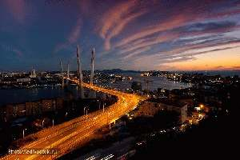
Evening walk in Vladivostok.
Friendship Evening 20.00
04.07.2020
05.07.2020
06/07/2020

Safari Park - Shamora and the Bay of Glass Ussuri Bay
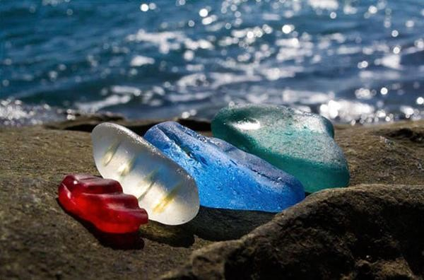 The Safari park by the sea has been laid out. The animals are on a piece of forest with a nice relief. The area of the Safari Park is 16 hectares. Many of the TV companies in the world, including BBC, my Planet, the call of the taiga, etc. Many times filmed Wildlife Safari Park for their films about wildlife in nature. Tigers from Safari-Park Amoer and taiga were filmed in the feature film Tiger Trail. Visitors look out of the bridges, without grids in front of tigers, leopard, large Himalayan bears, Kabarog and other deer. In the Safari Park there is a group of red wolves (animals that disappeared from the fauna of the Primorski kraj). Visitors observe the rarest animals without a barrier in front of their eyes. According to the magazine "Around the World" the Sea Safari Park, the only one in Russia, is one of the twelve best zoos in the world. The analytical bureau estimates Turstat The Seaside Safari Park is included in the top ten of the best thematic Parks in Russia.

